

A Constitution for Parents & Friends Associations
in Catholic Schools in Queensland
P&F Constitution
The Federation of Parents and Friends Associations of Catholic Schools in Queensland Inc.

GPO Box 2410
Brisbane Qld 4001

Ph 3336 9242
Fax 3210 0136

Email info@pandf.org.au
Web www.pandf.org.au

TABLE OF CONTENTS

Para Page

1. NAME 1
2. INTERPRETATION 1
3. OBJECTIVES 2
4. ASSOCIATION MEMBERSHIP 2
5. EXECUTIVE MEMBERSHIP 3
5.1 Membership of Executive 3
5.2 Election of Executive 3
5.3 Termination of Membership of Executive 3
5.4 Vacancies on Executive 4
5.5 Functions of the Executive 4
5.6 Sub-Committees 4
5.7 Meetings of the Executive 4
6. MEETINGS 5
6.1 Types of Meetings 5
6.2 Agenda of Annual General Meeting 5
6.3 Quorum 5
6.4 Calling of Meetings 5
6.5 Conduct of Meetings 6
7. ALTERATION OF CONSTITUTION 6
8. FUNDS 7
9. NO AGENCY OF THE SCHOOL 8
10. DISSOLUTION 8

PARENTAL CODE OF CONDUCT 9

BYLAWS 11

FOREWORD

The primary right of parents to educate their children must be upheld in all forms of collaboration between parents, teachers and school authorities, and particularly in forms of participation designed to give citizens a voice in the functioning of schools and in the formulation and implementation of educational policies.
(Article 5, U N Charter of the Rights of the Family)

The Catholic school participates in the evangelizing mission of the Church. It centres its vision on the life and teachings of Christ with the Gospels as the reference points of its philosophy. It is concerned with building a Christian community where parents, staff and students work together.

The Parents and Friends (P & F) Association is the formal structure, recognised by the Church and Catholic education authorities, which represents all the parents/carers in the school and acts in their interests and on their behalf.

The P & F Association exists to support the school community and is involved in the total life of the school. Parents/carers, as first educators of their children, have a vital collaborative role to play in the development and implementation of the educational philosophy and policy of the school.

The local P & F Association plays a significant role in the development of a collaborative and cooperative school community where parents/carers are recognised as authentic partners, with teachers and the administration, in the education of their children.

Parents and Friends Association Constitution

The Parents and Friends Federation has, over the years, provided a model constitution for use by the local school’s Parents and Friends Association.

The Constitution is the document which gives guidance to the local association for its efficient and effective operation. Hence the document:
- Sets common aims and objectives;
- Establishes rules for membership, elections, voting etc;
- Arranges for proper management of the finances;
- Allows for amendments and changes to be discussed, debated and resolved;
- Sets standards for appropriate community involvement; and
- Establishes other rules for the organisation's operation.

The following Constitution of the Parents and Friends Associations of Catholic Schools in Queensland, which supersedes all other model constitutions, has been drafted with the assistance and endorsement of Church authorities, legal advisers, parents and the Federation’s State Committee. It is a refinement and an updating of the Constitution that has been used by Parents and Friends Associations for some years.

This document recognizes that Parents and Friends Associations exist for the benefit of the school and its students. Each local association must be properly constituted and approved by Church and school authorities to ensure that it is eligible for insurance cover provided by the school, parish or diocese.

Officer bearers of the local association and the school Principal should ensure that copies of the constitution are readily available for perusal. Copies of the constitution are also available on the Federation’s website at www.pandf.org.au.

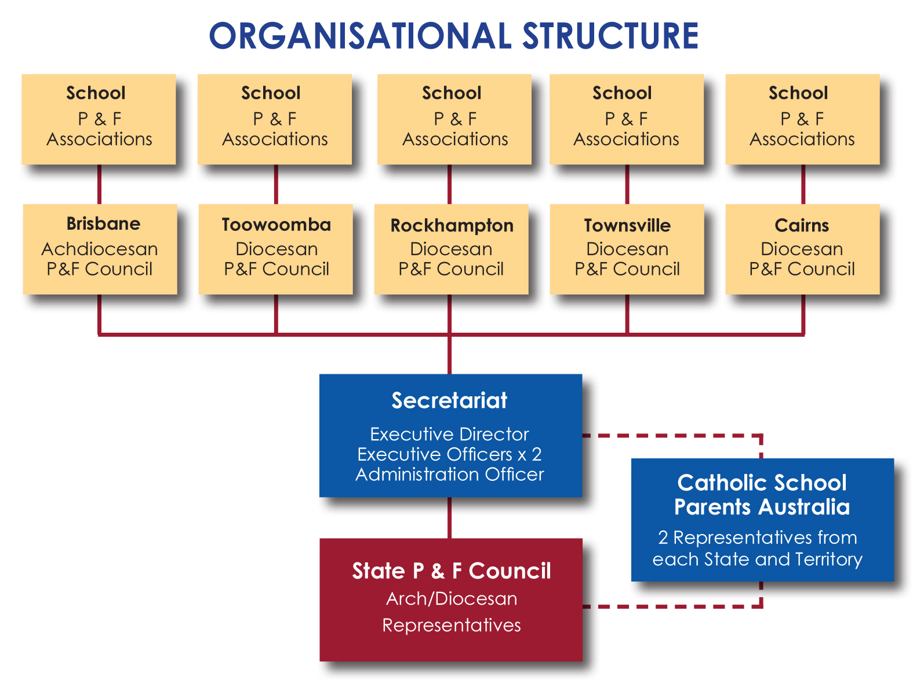

Name of School
Location

P&F ASSOCIATION

CONSTITUTION

Adopted at Special General Meeting [insert date of the Meeting]

Amended [insert date of meeting when amended]

1. NAME
The name of the Association shall be
[insert full name of Association].

- INTERPRETATION

In this Constitution unless the context otherwise requires:-
- “Parent/carer” means the natural parents, legal custodians or people who are ‘in loco parentis’ i.e. someone who is legally acting in place of a parent on behalf of a minor.
- “School” means any institution of pre-School, preparatory year, primary or secondary education conducted in accordance with Canon 803 of the Code of Canon Law.
- “Ordinary Member” is a Parent/Carer of a child enrolled at the School.
- “The Executive” means those “Ordinary Members” elected or appointed to fill the positions of President, Vice President, Secretary, Treasurer, Delegates to the Diocesan Council and School Principal and Parish Priest or others as elected to be “Executive Members”.
- “Ex-officio Members” are Members of the Executive of the Association by virtue of the office they hold. They shall have full voting rights.
- “Sub-Committees” means those “Ordinary Members” elected or appointed to particular committees (e.g. tuckshop, uniform) to fulfil specific roles and/or tasks that are agreed as required.
- “Delegate” means an “Ordinary member” appointed to “The Executive” to act as a representative on the Diocesan Council.
- “Diocesan Council” means the body representing the interests of all Parents and Friends Associations in a Diocese (including the Archdiocese) in the Roman Catholic province of Brisbane i.e. State of Queensland.
- “Federation” is the Federation of Parents and Friends Associations of Catholic Schools in Queensland, and is the body representing all Parents and Friends Associations in Catholic Schools in Queensland.
- “Annual Levy” is the fee applied by the Federation to the parents/carers of each child attending a Catholic School in Queensland. This levy shall be paid through each P&F Association annually.
- “Friends” are School teachers, staff, and other Members of the Parish / School community interested in pursuing the objectives of the P&F Association by their regular attendance at meetings. The names of “Friends” are to be agreed at an AGM or a regular meeting of the P&F Association.

- OBJECTIVES

  - The Objectives of the Association shall be those that accord with the content of the documents `The Catholic School' (Sacred Congregation for Catholic Education, Rome 1977), the Code of `Canon Law (1983)', and “The Catholic School on the Threshold of the Third Millennium” - Congregation for Catholic Education (For Seminaries and Educational Institutions).

  - In particular, the Association will participate in the optimum spiritual, intellectual, social and physical development of pupils in the School by:
- providing a medium of support, information and involvement of parents/carers in their children’s education and the School community
- developing collaboration between parents/carers and School staff.
- promoting the principles of Catholic education.
- fostering a distinctive Christian environment in the School.
- providing a medium for parents/carers to participate at Diocesan, State and National levels.

  - The Association shall:
- affiliate with the Federation of Parents and Friends Associations of Catholic Schools, Queensland and thereby its respective Diocesan P&F Council by payment of the Annual Levy.
- Work in partnership with the administration of the school in supporting all aspects of its operation.

The Association shall not:
- affiliate with any political body or party
- affiliate with any association whose objectives are inconsistent with the objectives stated in clause 3.1

- ASSOCIATION MEMBERSHIP

  - The membership of the Association shall consist of:

  - the parent/s and or carer/s of each child enrolled at the School who shall be called Ordinary Members;
  - the Parish Priest, and Principal or their nominees who shall be called Ex-Officio Members;
  - the Friends of the School.

  - Register of Members:

- In the case of those qualifying for Ordinary Membership as parents and/or carers of children currently on the School roll, the School roll shall be considered as the register of Members.
- The Executive shall cause a register to be kept in which shall be entered the names of all persons admitted to membership of the Association as “Friends”. The minutes of a meeting may be used as the register. Membership of a ‘friend’ shall be reviewed each year.

5. EXECUTIVE MEMBERSHIP

  - Membership of Executive shall consist of:

- President, Vice-President, Secretary, Treasurer and Diocesan Delegates.
- The Parish Priest and School Principal or their nominees as Ex-Officio Members.
- Representatives made up of Ordinary Members as agreed by the Association from time to time.

  - Election of the Executive

- At the Annual General Meeting of the Association, all the elected Members of the Executive shall retire from office, but shall be eligible for re-election or re-appointment subject to the terms of this Constitution.
- The Executive shall be elected from the Association membership by the Ordinary Members.
- Term of office of the elected Executive Members shall be one year with the right to serve a maximum of _______ [specify number of terms] consecutive full terms in the one position.
- Having served the maximum term in one position the member may stand for election for another position on the Executive.
- If an Executive member has served their maximum term (as per 5.2 c) and no nomination is forthcoming for that position, the Ordinary Members may re-appoint the encumbent to that position.

  - Termination of Membership of Executive

- Any member of the Executive may resign at any time from membership of the Executive by giving notice in writing to the Secretary. Such resignation shall take effect at the time when such notice is received by the Secretary unless some later date is specified in the notice when it shall take effect on that later date;
- Any member of the Executive may be removed from office at a specially convened meeting of the Association for that purpose if the member:-
  - Fails to comply with any of the provisions of this Constitution; or
  - Conducts him/her self in a manner considered to be injurious and
prejudicial to the character or interests of the Association. (See attached Parental Code of Conduct).
- The member concerned shall be given a full and fair opportunity of presenting his/her case, and if the Association resolves to terminate his/her membership it shall advise the member in writing within seven days accordingly.
- At any such specially convened meeting the member shall be given the opportunity to fully present a case. The question of removal shall be determined by the majority vote of the Members present at that meeting.
- In the case of resignation or removal of the Treasurer, the books and accounts shall be audited before handover to the newly appointed Treasurer.

  - Vacancies on Executive

- The Executive shall have power to appoint a member, who may or may not already be a member of the Executive, to fill any casual vacancy caused by the resignation or removal of an office bearer, on the Executive until the next Annual General Meeting.
- Such an appointment shall be ratified at the next scheduled General Meeting of the Association.

  - Functions of the Executive

Except as otherwise provided by this Constitution and subject to resolutions of the Members of the Association carried at any Annual or General Meeting the Executive shall:
- Manage the administration of the affairs, including the property and funds of the Association;
- Interpret and apply the Constitution with regard to any matter concerning the activities of the Association;
- Formulate bylaws for adoption, repeal or amendment by the General Meeting of the Association, designed to promote the good governance and management of the Association;

  - Sub-Committees

- The Executive shall have the authority to appoint Sub-Committees to undertake such tasks as it may from time to time determine. All Sub-Committees acting in accordance with the constitutional objectives shall be deemed to be a part of the Parents and Friends Association and must report back to the Association.
- Each Sub-Committee shall choose from its Membership a chairperson, secretary and, if needed, a treasurer.

  - Meetings of the Executive

- The Executive may meet separately from the General meeting as required during its term of office to exercise its functions. Decisions taken at meetings of the Executive shall be tabled at the next General Meeting for ratification or reporting purposes.
- A special meeting of the Executive shall be convened by the President or in his/her absence, the Secretary, upon the request of a simple majority of Members of the Executive. Such request shall clearly state the reason why such special meeting is being convened and the nature of the business to be transacted thereat.
- At every Executive Meeting a simple majority of the Members of the Executive shall constitute a quorum.
The Executive may meet together, subject to the constitution, and regulate its proceedings as it thinks fit, provided that questions arising at any meeting of the Executive shall be decided by consensus or a majority of votes and in the case of an equality of votes on any question at any meeting of the Executive the motion lapses so that the status quo is maintained.

6. MEETINGS

  - Meetings of the Association shall be either:

- Annual General Meeting. This shall be held in the month of ______ _____
[insert month] in each year.
- General Meeting. The Association shall meet at least six times per year exclusive of the Annual General Meeting
- Special General Meeting. This shall be called and held for a specific purpose.

  - Agenda of Annual General Meeting

The business to be transacted at every Annual General Meeting shall include:
- The reading of the minutes of the previous Annual General Meeting.
- Business arising from the minutes.
- The receiving of the President’s Report.
- The receiving of the Principal’s Report.
- The receiving of the Treasurer’s Report that shall include the Audited Financial Reports of the books and accounts of the Association for the preceding financial year including all Sub-Committees. (If Annual General Meeting is held prior to end of designated financial year, the audited books shall be received at the first meeting of the new year before handover to the new Treasurer.)
- The election of Members of the Executive.
- The appointment of Delegates to the Diocesan P&F Council;
- The appointment of Sub-Committees
- The appointment of an auditor.
- Review and distribution of Parental Code of Conduct
- The notification to the Diocesan Council, in writing within 30 days of the AGM, of the details of the office bearers for the Association.

  - Quorum

At the Annual General Meeting _____________ [insert a realistic number] Members shall constitute a quorum and at a General Meeting __________ [insert a realistic number] Members shall constitute a quorum.

  - Calling of Meetings

- The President or in his/her absence the Secretary shall convene all Annual and General Meetings of the organization by giving not less than fourteen days notice of such meetings. The Executive shall determine the manner by which such notice is given.
- The President or in his/her absence the Secretary shall convene Special Meetings of the Association when:
  - Directed to do so by the Executive or,
  - Upon being given a request in writing signed by not less than 1/3 of the Members of the Executive or not less than _________ [insert a number] Ordinary Members and clearly stating the purpose for which the Meeting has been requested.

  - Conduct of Meetings

Unless otherwise provided by this Constitution, at every Executive Meeting, Annual General Meeting, General Meeting and Special meeting:

a. The President shall be Chairperson or in his/her absence the Vice President and in the absence of both, a Chairperson shall be elected by resolution of a majority of the Members present at the meeting.
b. The Chairperson shall conduct all meetings in accordance with agreed and accepted rules for the conduct of meetings.(See parent manual)
c. Every question, resolution or decision shall be decided by consensus but should a deadlock occur a vote of all Members of the Association present will be taken and a majority decision shall apply.
d. Should a vote be required every member present shall be entitled to one vote. Where a vote is tied, the motion lapses so that the status quo is maintained.
e. Voting shall be by show of hands or a division of Members, unless a simple majority of Members present move that a secret ballot be conducted. The Chairperson shall appoint two Members to conduct the secret ballot in such manner as he/she shall determine. The result of the ballot as declared by the Chairperson shall be deemed to be the resolution of the meeting at which the ballot was demanded.
f. The Secretary shall cause full and accurate minutes of all questions, matters, resolutions and other proceedings of every meeting of the Executive, the Annual General Meeting, the General Meeting and any Special Meetings, to be entered in a book to be provided for that purpose. Such book is to be open for inspection at all reasonable times by any member of the Association who applies to the Secretary for that inspection.

7. ALTERATION OF CONSTITUTION

  - This Constitution may be amended at a Special General Meeting of the Association called for that purpose.

  - Notice of any proposed amendment shall be given in writing to the Secretary. The notice should be signed by [insert number] members who support the proposal. Immediately following receipt of such Notice, the secretary shall notify the terms thereof to the Ordinary Members, with the date, time and place of the Special General Meeting called for that purpose. The meeting shall take place within one calendar month of the notice of the meeting called for that purpose.

8. FUNDS

  - The income and any property of the Association shall be used and applied solely in promotion of its objectives and in the exercise of its powers and no portion shall be distributed directly or indirectly to the members of the Association except as genuine compensation for services rendered or for expenses incurred on behalf of the Association in promotion of its objectives.
  - The financial year of the Association shall be from 1st January to 31st December.
  - The funds of the Association shall be banked in the name of ______________________
_______________________________________________________________________
[full name of Association] in the Local Diocesan/Archdiocesan Development Fund as directed. If no such direction exists then a bank or financial institution as the Annual General Meeting or a General Meeting may from time to time direct.
  - Proper books and accounts shall be kept and maintained showing correctly the financial affairs of the Association, and the particulars usually shown in books of like nature. Such books are to be open for inspection at all reasonable times by any member who applies to the Secretary for that inspection. The treasurer should present an updated report to each General Meeting.
  - All moneys shall be banked as soon as practicable after receipt of them.
  - All accounts other than petty cash transactions shall be signed by any two of a group of four Members of the Executive. Cheques shall be crossed `Not Negotiable' except those in payment of allowances or petty cash recipients, which may be open. Should the association decide to use an electronic payment system; the following controls must be established and maintained for EFT payments of supplier accounts:
- All EFT transactions are to be authorised by two account signatories by entering:
    - a user name and password, or
    - a user name and the randomly generated pin if using a security token (highly recommended if the financial institution offers this level of security);
- the two account signatories are to sight, check and approve all documentation before an EFT transfer is authorised;
- a confirmation email or screen receipt which is generated by the financial institution following the entry of an EFT transaction must be printed and filed for audit purposes;
- a printed record of any transaction deleted or edited must be made and filed for audit purposes;
- a receipt/record of all electronic fund transfers for each payment must be printed and attached to the relevant document (invoice) and filed for audit purposes.
  - The Executive shall determine the amount of petty cash that shall be available. The Monthly meeting of the Association shall ratify this amount. The use of Petty Cash will be reported in the Treasurers Report at each Monthly Meeting of the Association.
  - Accounts for payment, consistent with Clause 5.5, shall be presented and passed at an Executive Meeting and/or subsequently endorsed by the next General Meeting.
  - The Association shall not borrow money except:
- In accordance with Clause 9 below,
- For the furtherance of its objectives, and
- Where a Special Meeting called for that purpose has granted approval.
  - The Association shall, where possible, manage all funds in accordance with an annual budget.
  - As soon as practicable after the end of each Financial Year, the Treasurer shall cause to be prepared a statement of receipts and payments, income and expenditure, and a balance sheet for the financial year just ended. All such statements shall be examined by the auditor, who shall present his/her report to the Secretary prior to the holding of the next Annual General Meeting following the financial year in respect of which such audit was made.
  - If the Annual General Meeting is held prior to the end of the financial year a Financial Report will be presented to the meeting. The audited Financial Report shall be presented to the first General Meeting after the end of the financial year.
  - The Treasurer of the Association or of a Sub-Committee will hand to the successor in office all records and accounts of the Association or Sub-Committee, as soon as the successor has been appointed.
  - If a Treasurer of the Association or of a Sub-Committee resigns during the term of office, the Association should arrange for an audit of the records and accounts of the Association or Sub-Committee to be carried out before handing these to the new Treasurer.

9. NO AGENCY OF THE SCHOOL

  - The Association will not hold itself out as agent of the School and has no Authority to bind the school.

  - Any decisions in relation to contractual matters are to be reached by consensus and discussed with the School principal and the parish priest and entered into by the proper authority.

10. DISSOLUTION

  - The Association shall be dissolved:
- If the Membership is less than three persons, or
- If a resolution to that effect is carried by a vote of three-fourths majority of the Members present at a Special Meeting convened to consider the question.

  - In such event, the property and other assets of the Association remaining after the payment of all expenses and other liabilities shall, as the majority of Members present at such General Meeting by resolution may decide, be handed over to:
- The School
- The Bishop of the Catholic Diocese of [insert name of Arch/Diocese], or
- An Association within the Catholic Church having similar objectives.

CERTIFICATION

We certify that this is a true and correct copy
of the Constitution of

(NAME OF ORGANIZATION)

(PRESIDENT) |  | (SECRETARY)

DATE:

Parental Code of Conduct

Introduction

____________________________________________________________________________ is a Catholic School within the Arch/Diocese of _____________________________________
(You can insert here some information from the enrolment form and/or the School’s mission statement.)

This Code of Conduct is intended to provide school community Members with guidelines for the effective conduct of meetings and the development of positive relationships within the School community.

General Conduct

Community Members agree to;

- Support the Principal and staff in the development of a Christ-centred learning community based upon the principles of Catholic doctrine;

- Support the School’s policies developed in consultation with all stakeholders.
The Principal has the responsibility to implement these policies;

- Accept responsibility for their child’s/children’s progress and work with the teaching staff to deal promptly with areas of concern;

- Treat all Members of the School community with respect and courtesy; and

- Acknowledge and affirm success in individual and School achievement.

Conduct at Meetings

The regular Parents and Friends Association meeting is an opportunity for community Members to contribute to discussion on issues and to take decisions that will have a positive impact on the School community.
To ensure that this is carried out effectively, community Members agree to;

- conduct activities in accordance with the Constitution of the P&F Association,

- participate in P&F Association meetings and other community activities in a
constructive manner and respect the views of others,

- acknowledge that the decisions taken and actions proposed at the P&F Association meetings are representative of the majority of the School community,

- adhere to the processes available to have issues addressed and decisions reviewed,

- support the President and Members of the P&F Executive when they are required to make decisions on behalf of all parents in the School community, and

- use appropriate conduct when participating in meeting discussions and promote positive personal relationships among community Members.

Conduct Unbecoming

If a community member is in breach of this code, the President of the P & F Association will meet with the Principal to decide appropriate action. The Principal’s decision will be final and binding on community Members.

ADOPTED ON: [DATE]

(PRESIDENT) |  | (SECRETARY)

BYLAWS
Attach your P&F Association’s bylaws on this page.

A bylaw is a law made by your local Parents and Friends Association pertaining to a particular issue. They must relate to functions and powers of the P&F Association.
Examples:-
- Meeting of St Josephs P&F Association must not be longer than 1½ hours without a motion from the meeting being passed to allow for special circumstances. [25 May 2003].
- A P&F fundraising levy will be levied on every family at St Josephs School at the rate of $50 per student annually (to a maximum of $100 per family). This levy will be collected on the school fees at a rate of $12.50 per term per student and then passed to the P&F Association by the school. [25 August 2003].

